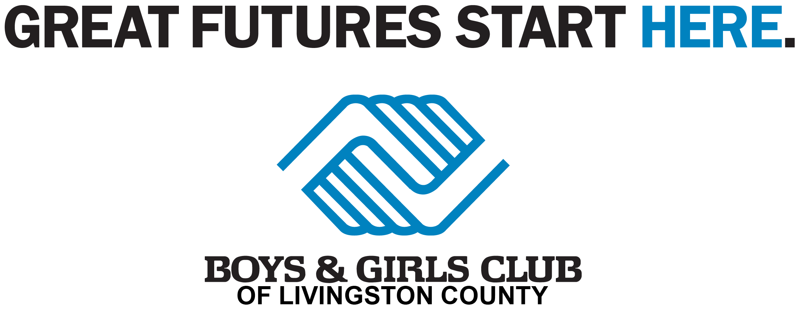
IN-KIND DONATION FORM
Thank you for your support!

Thank you very much for making an in-kind donation to the Boys & Girls Club of Livingston County. This form will help us to properly record and acknowledge your generous gift. If you have any questions, please contact us at 815-842-3089.

Donor Information:

Donor is: □ Individual □ Organization/Company

Donor Name (as it should appear on receipt and in print): _____________________________________________
Name of Contact Person (for Organization/Company): ___________________________________________
Address: _________________________________________________________________________________
City: __________________________________ State: _____________ Zip: __________________
Telephone: _______________________________ Home □ Work □ Cell □
Email: ___________________________________________________________
Item Information:

Item Description: _________________________________________________________________________
________________________________________________________________________________________
________________________________________________________________________________________
Estimated Fair Market Value of Item: $______________________ (Determined by Donor)
Donor Signature:

Donor Signature: ________________________________________________ Date: ___________________
The Donor Signature line must be signed to verify that the “estimated fair market value” amount was provided by the actual donor.

The Boys & Girls Club of Livingston County is a 501(c)(3) nonprofit organization, therefore, your donation may be tax deductible as allowed by law. Tax I.D. No. 37-0975574. Per IRS regulations, any item you value over $500 requires IRS Form 8283; any item you value over $5,000 requires Form 8283 and a written appraisal. The IRS requires, for our records and yours, that an estimation of the dollar amount of a non-cash contribution be given.

